**LAKEWOOD COUGARS**

**Scouting Report**

Lakewook has a good program, they are well coached and disciplined.

Lakewood did not do well in their first two games, but they showed signs of greatness at times. We are going to have our hands full with the QB who is 6'3 200 pounds. He is mobile, but doesn't look to run the ball he would rather keep his eyes downfield and make a play. This means corners we have to get ready to cover for extended periods of time.

They don't run much, but when they do it will be lots of traps so here comes the pulling gaurds and tackles which means we get another opportunity to set the edge, but do it correctly this week.

**GUYS TO WATCH:**

| [#](http://www.maxpreps.com/high-schools/lakewood-cougars-(north-lakewood,wa)/football/stats.htm) | [Athlete Name](http://www.maxpreps.com/high-schools/lakewood-cougars-(north-lakewood,wa)/football/stats.htm) | [GP](http://www.maxpreps.com/high-schools/lakewood-cougars-(north-lakewood,wa)/football/stats.htm) | [C](http://www.maxpreps.com/high-schools/lakewood-cougars-(north-lakewood,wa)/football/stats.htm) | [Att](http://www.maxpreps.com/high-schools/lakewood-cougars-(north-lakewood,wa)/football/stats.htm) | [Yds](http://www.maxpreps.com/high-schools/lakewood-cougars-(north-lakewood,wa)/football/stats.htm) | [Avg](http://www.maxpreps.com/high-schools/lakewood-cougars-(north-lakewood,wa)/football/stats.htm) | [Y/G](http://www.maxpreps.com/high-schools/lakewood-cougars-(north-lakewood,wa)/football/stats.htm) | [C/G](http://www.maxpreps.com/high-schools/lakewood-cougars-(north-lakewood,wa)/football/stats.htm) | [TD](http://www.maxpreps.com/high-schools/lakewood-cougars-(north-lakewood,wa)/football/stats.htm) | [TD/G](http://www.maxpreps.com/high-schools/lakewood-cougars-(north-lakewood,wa)/football/stats.htm) | [Int](http://www.maxpreps.com/high-schools/lakewood-cougars-(north-lakewood,wa)/football/stats.htm) | [Lng](http://www.maxpreps.com/high-schools/lakewood-cougars-(north-lakewood,wa)/football/stats.htm) | [QB Rate](http://www.maxpreps.com/high-schools/lakewood-cougars-(north-lakewood,wa)/football/stats.htm) |
| --- | --- | --- | --- | --- | --- | --- | --- | --- | --- | --- | --- | --- | --- |
| 9 | [A. Lane](http://www.maxpreps.com/local/player/stats.aspx?athleteid=73b98432-bb24-4775-b7f9-f2c070f60d26&ssid=c81b47ee-f434-456f-8f6e-fee79c115904) (Jr) | 2 | 50 | 89 | 568 | 11.4 | 284.0 | 25.0 | 6 | 3.0 | 1 | 41 | 93.3 |

| [#](http://www.maxpreps.com/high-schools/lakewood-cougars-(north-lakewood,wa)/football/stats.htm) | [Athlete Name](http://www.maxpreps.com/high-schools/lakewood-cougars-(north-lakewood,wa)/football/stats.htm) | [GP](http://www.maxpreps.com/high-schools/lakewood-cougars-(north-lakewood,wa)/football/stats.htm) | [Car](http://www.maxpreps.com/high-schools/lakewood-cougars-(north-lakewood,wa)/football/stats.htm) | [Yds](http://www.maxpreps.com/high-schools/lakewood-cougars-(north-lakewood,wa)/football/stats.htm) | [Avg](http://www.maxpreps.com/high-schools/lakewood-cougars-(north-lakewood,wa)/football/stats.htm) | [Y/G](http://www.maxpreps.com/high-schools/lakewood-cougars-(north-lakewood,wa)/football/stats.htm) | [Lng](http://www.maxpreps.com/high-schools/lakewood-cougars-(north-lakewood,wa)/football/stats.htm) | [100+](http://www.maxpreps.com/high-schools/lakewood-cougars-(north-lakewood,wa)/football/stats.htm) | [TD](http://www.maxpreps.com/high-schools/lakewood-cougars-(north-lakewood,wa)/football/stats.htm) |
| --- | --- | --- | --- | --- | --- | --- | --- | --- | --- |
| 1 | [S. Neiffer](http://www.maxpreps.com/local/player/stats.aspx?athleteid=e206cb4b-30d3-431a-8d93-4a5b0e730740&ssid=c81b47ee-f434-456f-8f6e-fee79c115904) (So) | 2 | 10 | 54 | 5.4 | 27.0 | 19 | 0 |  |
| 27 | [J. Stenberg](http://www.maxpreps.com/local/player/stats.aspx?athleteid=3833a212-012c-41aa-ae1b-2505e32f1cd9&ssid=c81b47ee-f434-456f-8f6e-fee79c115904) (Sr) | 1 | 10 | 58 | 5.8 | 58.0 | 23 | 0 |  |
| 40 | [M. Ramirez](http://www.maxpreps.com/local/player/stats.aspx?athleteid=09de2995-d41d-4dc6-8113-c79c53ecd122&ssid=c81b47ee-f434-456f-8f6e-fee79c115904) (Sr) | 2 | 10 | 40 | 4.0 | 20.0 | 18 | 0 | 1 |

| [#](http://www.maxpreps.com/high-schools/lakewood-cougars-(north-lakewood,wa)/football/stats.htm) | [Athlete Name](http://www.maxpreps.com/high-schools/lakewood-cougars-(north-lakewood,wa)/football/stats.htm) | [GP](http://www.maxpreps.com/high-schools/lakewood-cougars-(north-lakewood,wa)/football/stats.htm) | [Rec](http://www.maxpreps.com/high-schools/lakewood-cougars-(north-lakewood,wa)/football/stats.htm) | [Yds](http://www.maxpreps.com/high-schools/lakewood-cougars-(north-lakewood,wa)/football/stats.htm) | [Avg](http://www.maxpreps.com/high-schools/lakewood-cougars-(north-lakewood,wa)/football/stats.htm) | [Y/G](http://www.maxpreps.com/high-schools/lakewood-cougars-(north-lakewood,wa)/football/stats.htm) | [Lng](http://www.maxpreps.com/high-schools/lakewood-cougars-(north-lakewood,wa)/football/stats.htm) | [TD](http://www.maxpreps.com/high-schools/lakewood-cougars-(north-lakewood,wa)/football/stats.htm) |
| --- | --- | --- | --- | --- | --- | --- | --- | --- |
|  | Season Totals | 2 | 50 | 568 | 11.4 | 284.0 | 41 | 6 |
| 13 | [T. Tresch](http://www.maxpreps.com/local/player/stats.aspx?athleteid=33423d55-2f3d-4fc5-8bd3-691a18bb4ff6&ssid=c81b47ee-f434-456f-8f6e-fee79c115904) (Sr) | 2 | 16 | 153 | 9.6 | 76.5 | 26 |  |
| 39 | [B. Schubert](http://www.maxpreps.com/local/player/stats.aspx?athleteid=cb56eb96-b795-4f91-ba33-5ec55c0fe89f&ssid=c81b47ee-f434-456f-8f6e-fee79c115904) (Sr) | 2 | 4 | 94 | 23.5 | 47.0 | 41 | 1 |
| 88 | [J. Cox iii](http://www.maxpreps.com/local/player/stats.aspx?athleteid=62b7a242-2ed8-40f4-8ee4-e9826ee977fe&ssid=c81b47ee-f434-456f-8f6e-fee79c115904) (Jr) | 2 | 14 | 196 | 14.0 | 98.0 | 23 | 3 |

***In order to win this game we have to play at 100 miles an hour. We have to be willing to sacrifice our bodies and blow up blockers so that other guys can make plays. We have to believe that we can win and then we have to live that belief through our preparation.***

**Breakdown:**

***Formation Run% Pass % Fav Run Fav Pass***

|  |  |  |  |  |
| --- | --- | --- | --- | --- |
| **Trips L** | 19% | 81% | Trap L | 3 verts 1 hitch |
| **Trips R** | 17% | 83% | Trap L | 3 hitches w/vert |
| **Doubles** | 14% | 86% | N/A | N/A |
| **Trips Stack L** | 29% | 71% | N/A | N/A |
| **Empty** | 0% | 100% | N/A | N/A |

This week:

Defense:

Southside, Titanium

Coverages:

Southside, Storm, sky,lightening, cloud, Hood, Mayham

Blitzes:

Miami, Baltimore, Fire,Ice,hawaii,houston,Reno,LA, 2M, 2O, Hood, Mayham

Shifts:

Rattle, Lion, Heads, Over, Under

Alignment:

Heads, Over

TRIPS TRIPS TRIPS!

***Film Questions***

***DL***

1. How to beat a slow space eating O-lineman?

2. What are Lakewood's favorite formations to run the ball in ?

3. Who is their best and worst O-lineman?

4. What is Lakewood's favorite run play?

5. What is one thing you can do to make the team better?

***LB***

1. What play/plays do Lakewood pull both guards?

2. What is their favorite run play?

3. Which hand does quarterback throw with?

4. What do you do when tackle to your side down blocks?

5. What do you do when tackle to your side pulls?

***DB***

1. Is the QB left or right handed?

2. Most targeted WR?

3. What is their favorite pass formation and what % do they pass out that formation?

4. What is your job in sky?

5. What is the difference between man turn and zone turn?

5. Favorite pass formation?

Asteroid

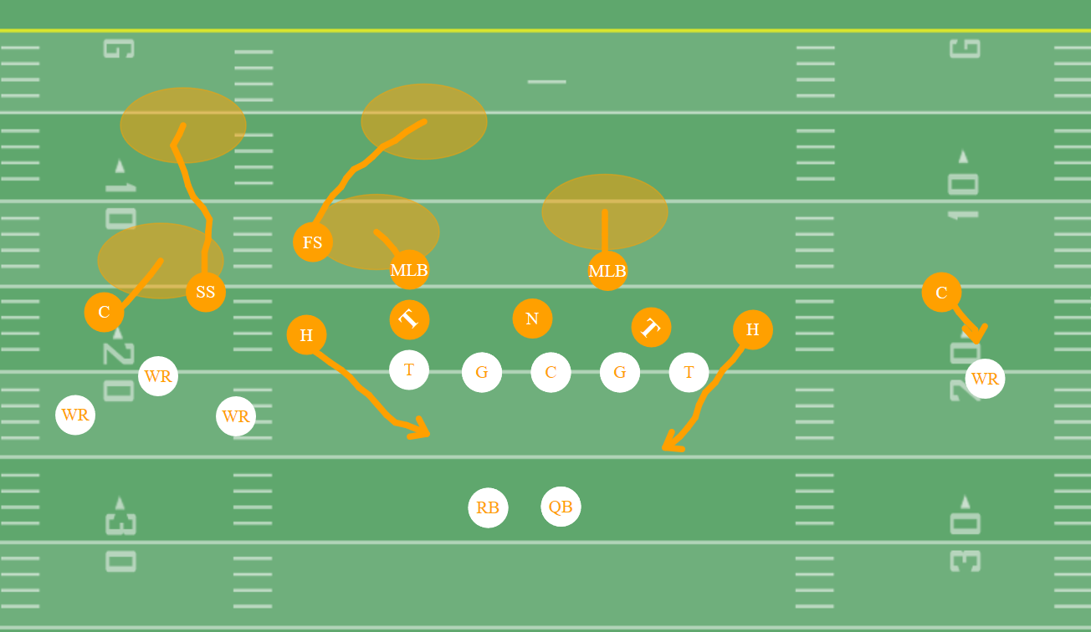

Rain

